We Will Overcome Obstacles to Your Destiny
May 24, 2017
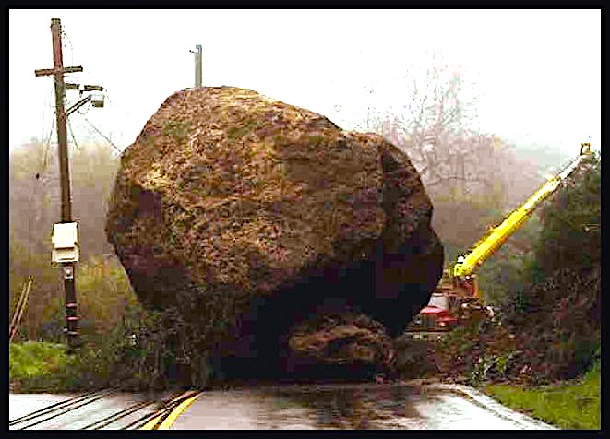
My precious Heartdwellers, if the last few weeks have been exceptionally difficult, please take heart! The Lord is with you and has encouragement for our flagging hearts and minds.

After Communion, the Lord said, "May I speak with you?" And He began, "These days are critical, My Clare. I know how much they are costing you. I know all about your battles with fatigue and attitudes. I know how you struggle with frustration that you cannot change some things that cause others pain. I know how you grieve over all these things, even your breathing.

“But may I say, you are bringing down truckloads of graces upon this Channel by your cooperation with these sufferings. Though I know you want to give up at times, still you haven’t; you are still, saying , “yes” to Me. I commend you for that. Understand, these are critical times and your shares of suffering are important to My plans. Thank you for persevering, My Love, thank you."

I answered, 'Lord, thank You for giving me the grace to do so.'

"I will always give you the grace. Always."

Oh, thank you, Lord. that is encouraging. Sometimes I wonder...

“Now, about the red balloon you let go."

That's a message I put up, I think a week ago or so. About letting go when it's time to let go. I had felt called to try again to reconcile this situation with Him, and haven't received any feedback. So, the Lord began to speak to me about it.

And He said, "I see your pain. I see the pain in the other. I see all the sins entwined in a mess. But you have now done what you could and I want you to let go again. I do not want this dragging on and on and on, down and down and down. Enough is enough. You made the overture, that is what I was requesting of you. Not results, but the overture. I know this pains you, but you are clean before Me, Clare, very clean and it’s time to move on. We are going over the rainbow."

Oh, gosh... I feel like I'm going under the sludge! I said, 'Lord, I feel like a slug in the slime watching the sparkling white doves flying over the rainbow with You and I’m stuck on the underside of this leaf, making slime, smelling like slime, feeling like slime...just being slimy.

He answered me, "That’s very cute but it’s poisonous self-pity. So, let’s not be so slimy. Shall we soar together?"

Can You lift a heart that feels like it weights 2,000# over that rainbow??

He said unequivocally, “I can!”

Take me away, Lord... Take me away!

He continued, "Oh so deep are those feelings of failure when you can not alleviate the sufferings of a loved one. But cast these lies aside. Enduring through these trials is part of your suffering to My very, very important cause. I need you to stand straight and strong and I will bring good out of it all. You are not a failure, far from it. You have done as I wished, that’s all I wanted. The results are now in My court."

And at that point, we had company and I had to get up to tend to something. And I came back and said, 'Lord, was there anything else, Lord?'

He picked up where He'd left off, and said, "The road of creativity, be it in the arts or administering, organizing…the road of creativity is beset by many bumps and potholes. The secret to becoming who I made you to be is to weather these contradictions and bounce back stronger.

"Because you have My Body and Blood in communion, you can draw your strength from that each day. You have My words to meditate on, and My Spirit to quicken you. And because you have My waiting arms to come to with your petitions, I can fill you to overflowing for the tasks of the day, or I can repair the wounds of the night before. There is no limit to what I can accomplish in My Bride when she avails herself of Me alone.

"What is not understood about journeys to fulfillment in your lives, is the fact that potholes and broken bits of pavement that you must pass over, create greater depth and insight into the human dimension. Which, in turn, stirs up new avenues of creativity in you. Were your journey to be smooth and peaceful, you would grow weary with boredom and lose inspiration for your work. These painful situations bring inspiration."

And it's interesting, a lot of things have come to me while I was in tears, doing the dishes, sweeping the floors - doing some kind of menial housework. So, I understand well what He's saying here.

He continued, "The broken asphalt, potholes, roads washed away and bridges out create an atmosphere for victory over obstacles by presenting you with challenges. You also are experiencing emotions and thought patterns that must be taken captive and brought into My light of Truth to be conquered and turned from evil to good.

"These challenges raise your understanding, giving you many opportunities to think and act creatively, the way I think and act. And also that good may come of even the most distressing situations. The sufferings that accompany them also form you more deeply in patience and perseverance. All in all, I allow contradictions in your lives to make you whole and entire, lacking in no good thing, going from glory to glory.

"And in turn, your experiences bring resolution to the needs of others facing similar trials. They are not to be feared My Brides, but to be eagerly anticipated as a means of perfecting your Love for Me and your neighbor."

Oh, Lord - that'll be the day when I eagerly anticipate trials! That will be the most grace-filled day of my life...

"Do not recoil in fear, My love. Rather embrace the possibilities, and we will cross these broken bridges together. So many people never reach their potential, because they spent their lives avoiding any kind of trouble, contradiction, pain, suffering, a lack of things. Any difficult challenge - they avoid it! How sad this is. They will, at their departure from Earth, feel woefully lacking in accomplishment.

"But for those of you who want to attain to the stature I preordained for you, obstacles and challenges are the rungs of a ladder carrying you all to completion…that is if you continue on the ladder and don’t decline. And don't turn back!

"So, don’t give up, don’t look back, take firm hold of the tow-rope of grace and allow Me to empower you to cross over raging rivers and keep climbing ladders that disappear in the clouds. For that is your destiny."

